Homework 1 for Informational Networks – read chapters1.6 and 1.7

R16

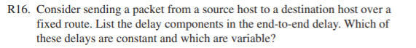

Processing delay (fixed), transmission delay (fixed), propagation delay (fixed), queuing delay (variable)

R18

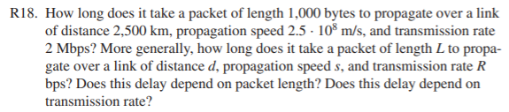

Transmission delay: packet length (L)/transmission rate (R) = (1000 bytes \* 8 bits)/2E6 bits

= 4 ms

Propagation delay: distance (d)/ propagation speed(s) = 2500000 m / 2.5E8 m/s = 10 ms

Total delay = 14 ms. Yes, delay does depend on packet length (needed to find transmission delay) and transmission rate.

R19

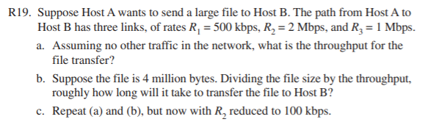

1. Throughput can only be as fast as the slowest link, so in this case, 500 kbps
2. 4E6\*8(bytes to bits) / 500E3 = 64 sec
3. Since 100 kbps is less than 500 kbps, the throughput is reduced to 100 kbps.

T = 4E6\*8 / 100E3 = 320 sec

R26



Viruses enter the system by a user’s interaction. Worms require no such interaction, and can therefore enter undetected.

P2 and P3

Equation 1.1: 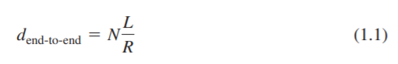

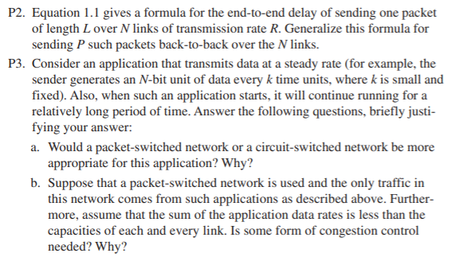

P6

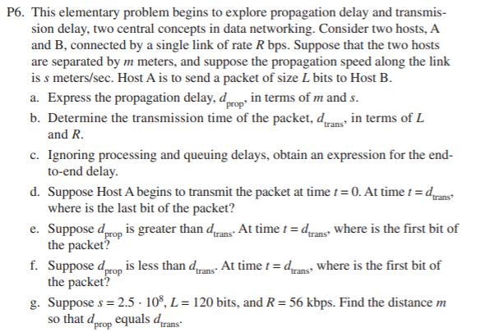

P10

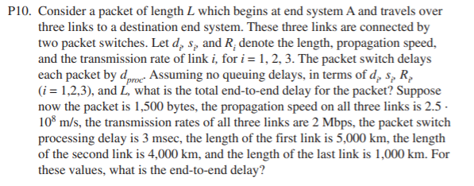

P31

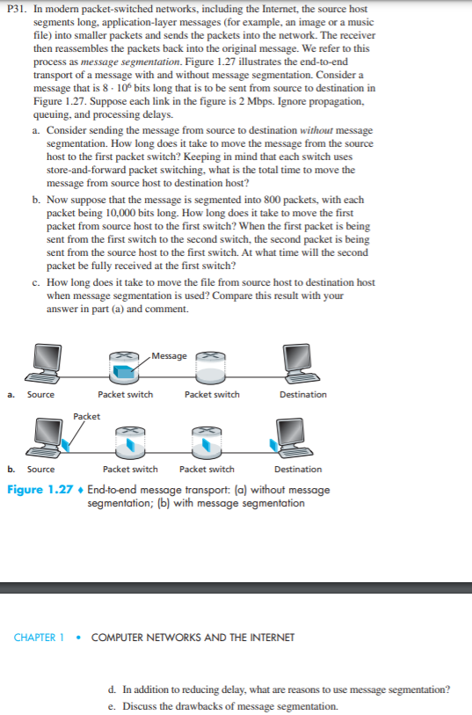

P33 and 34

